Stack Visualization

Group Name
GROUP 4

Group Members
- RHEIN HALE MANREAL
- EMMANUEL HAMLAG
- CYD ABARIENTOS
-JURIEN EARL MAPA
- RYAN MARK DATULAYTA

Description
Stack Visualization is a Java Swing application that demonstrates
the Last-In, First-Out (LIFO) principle using a 2D graphical stack.

The application uses an array-based stack with a maximum capacity
of 10 elements. Users can perform stack operations and observe
the changes visually.

Features
- Push an integer onto the stack
- Pop the top element
- Peek at and highlight the top element
- Clear the stack
- Check whether the stack is empty
- Generate a randomized stack
- Display the current stack size
- Handle stack overflow and underflow
- Display the current stack vertically

## Requirements
- Java Development Kit (JDK)
- Apache NetBeans or Visual Studio Code with Java support
- Git for version control

How to Run
1. Clone the repository.
2. Open the project in your Java IDE.
3. Ensure the package is named stackvisualization.
4. Open StackVisualizerGUI.java.
5. Run the main method.

Project Structure
src/stackvisualization/
- StackArray.java
- StackPanel.java
- StackVisualizerGUI.java

Stack Implementation
The application uses a fixed-size integer array with capacity 10.
The top variable identifies the index of the last inserted element.

The implementation provides push, pop, peek, isEmpty, isFull,
size, clear, and getElementAt methods.

Screenshots
Add screenshots of:
- The empty stack
- PUSH operations
- POP operation
- PEEK operation
- RANDOM operation
- CLEAR operation
- Overflow and underflow handling

AI Disclosure
AI tool: ChatGPT by OpenAI, GPT-6.

Purpose: Assisted with explaining the assignment, drafting example
Java code, suggesting GUI structure, and preparing documentation.

Prompt: "Help implement a Java Swing stack visualizer with a separate
array-based Stack ADT, a maximum capacity of 10, push, pop, peek,
clear, check stack, random, size, a 2D visualization, and boundary
condition handling."

Extent of use: [Describe the actual extent of AI assistance.]

Human verification: The group reviewed, tested, and modified the
AI-assisted output before submission. [Confirm only after doing so.]

Estimated AI-assisted portion: [Insert your honest estimate.]

Changes made by the students: [List the actual changes.]

What we learned: [Explain what the group learned about stacks,
Java, GUI programming, testing, and AI-assisted development.]

## Contributors
List all group members and summarize their actual contributions.

JURIEN EARL MAPA – Helping through debugging
RHEIN HALE MANREAL – Helping through paper works
CYD ABARIENTOS – Helping through debugging
EMMANUEL HAMLAG – Group facilitator
RYAN MARK DATULAYTA – Documenting

SCREENSHOT (DOCUMENTATION):
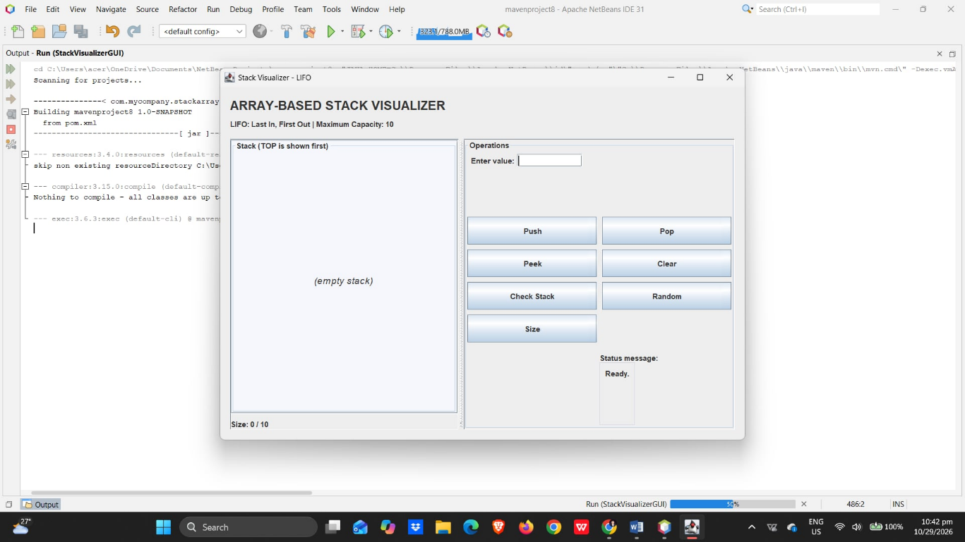

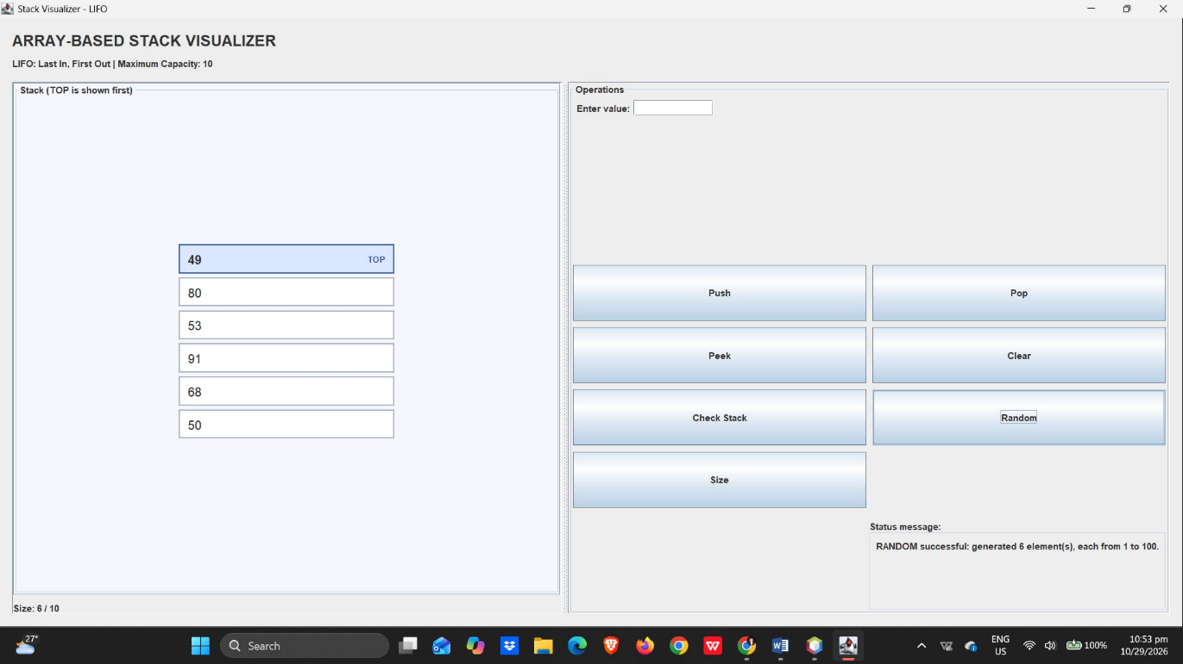

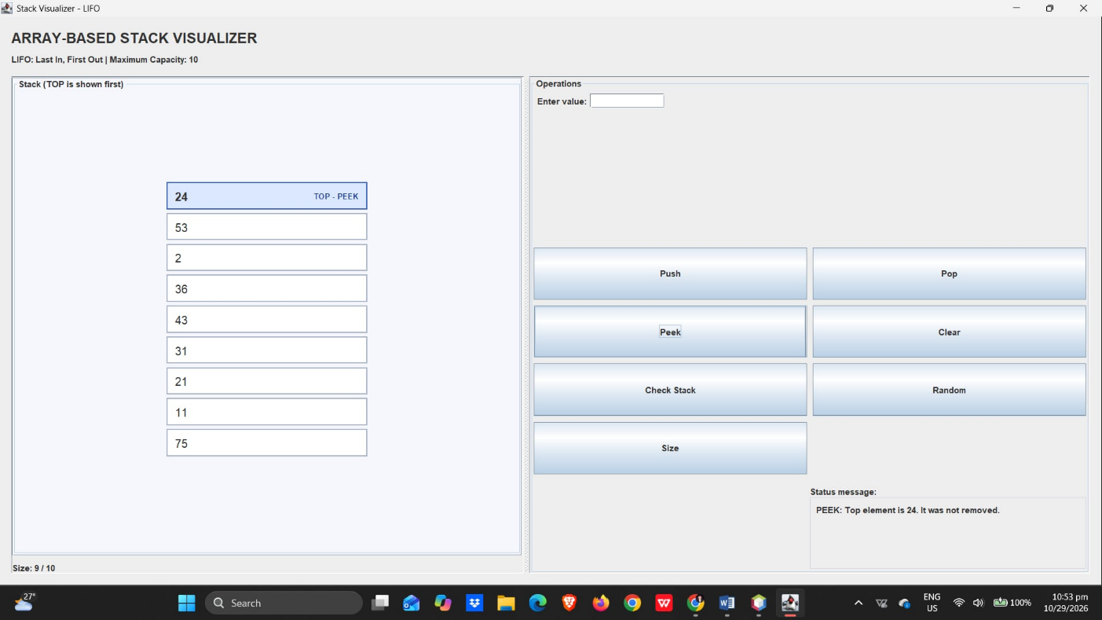

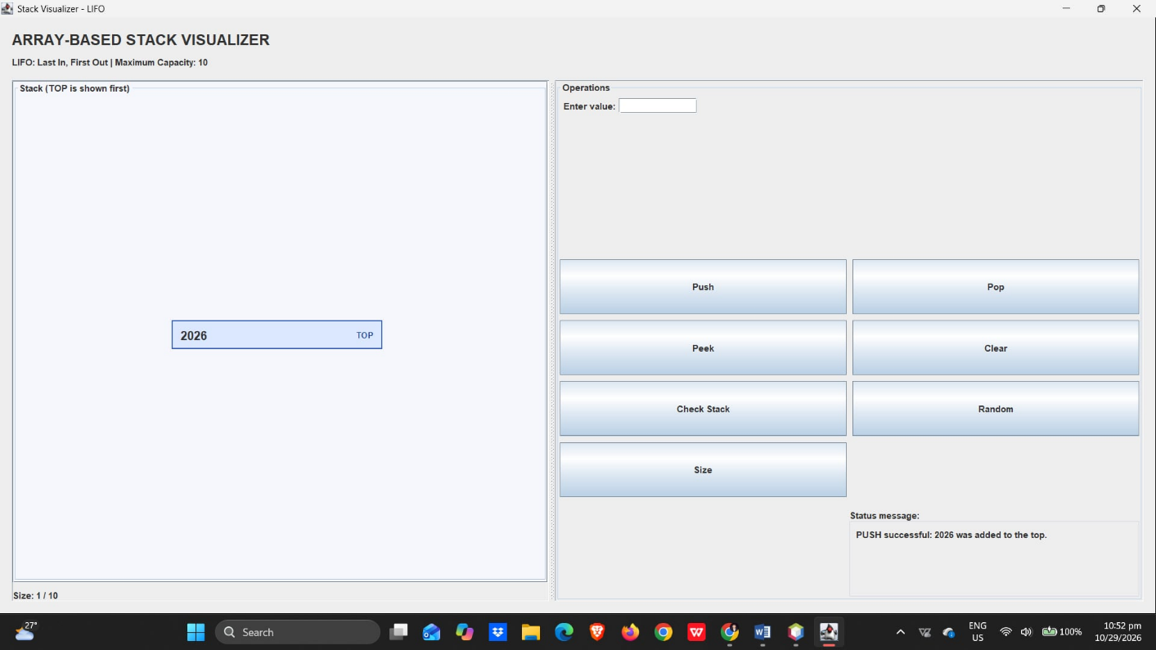

CODE SAMPLE:

package com.stackvisualizer;

import javax.swing.*;
import javax.swing.border.EmptyBorder;
import java.awt.*;
import java.util.Arrays;
import java.util.Random;

// =====================================================
// STACK CLASS
// =====================================================
class ArrayStack {

public static final int CAPACITY = 10;

private final int[] elements = new int[CAPACITY];
private int top = -1;

public void push(int value) {
if (isFull()) {
throw new IllegalStateException(
"STACK OVERFLOW: Cannot push, stack is full."
);
}

elements[++top] = value;
}

public int pop() {
if (isEmpty()) {
throw new IllegalStateException(
"STACK UNDERFLOW: Cannot pop, stack is empty."
);
}

return elements[top--];
}

public int peek() {
if (isEmpty()) {
throw new IllegalStateException(
"EMPTY STACK: Cannot peek because the stack is empty."
);
}

return elements[top];
}

public boolean isEmpty() {
return top == -1;
}

public boolean isFull() {
return top == CAPACITY - 1;
}

public int size() {
return top + 1;
}

public void clear() {
top = -1;
}

public int[] toArray() {
return Arrays.copyOf(elements, top + 1);
}

public int randomize(Random random) {
clear();

int count = random.nextInt(CAPACITY) + 1;

for (int i = 0; i < count; i++) {
push(random.nextInt(100) + 1);
}

return count;
}
}

// =====================================================
// GUI CLASS - MAIN CLASS
// =====================================================
public class StackVisualizerGUI extends JFrame {

private static final int GAP = 8;

private final ArrayStack stack = new ArrayStack();

private final JTextField valueField = new JTextField(10);
private final JPanel stackPanel = new JPanel();
private final JLabel statusLabel = new JLabel("Ready.");
private final JLabel sizeLabel = new JLabel("Size: 0 / 10");

private final Random random = new Random();

public StackVisualizerGUI() {

super("Stack Visualizer - LIFO");

setDefaultCloseOperation(JFrame.EXIT_ON_CLOSE);
setSize(850, 600);
setMinimumSize(new Dimension(650, 500));
setLocationRelativeTo(null);

JPanel root = new JPanel(new BorderLayout(12, 12));
root.setBorder(new EmptyBorder(16, 16, 16, 16));
setContentPane(root);

// HEADER
JLabel heading = new JLabel("ARRAY-BASED STACK VISUALIZER");
heading.setFont(new Font("SansSerif", Font.BOLD, 20));

JLabel subtitle = new JLabel(
"LIFO: Last In, First Out | Maximum Capacity: 10"
);

JPanel header = new JPanel(new GridLayout(2, 1, 4, 4));
header.add(heading);
header.add(subtitle);

root.add(header, BorderLayout.NORTH);

// STACK VISUALIZATION
stackPanel.setLayout(
new BoxLayout(stackPanel, BoxLayout.Y_AXIS)
);

stackPanel.setBorder(
BorderFactory.createTitledBorder(
"Stack (TOP is shown first)"
)
);

stackPanel.setBackground(new Color(245, 247, 252));

JScrollPane scrollPane = new JScrollPane(stackPanel);
scrollPane.setPreferredSize(new Dimension(350, 400));

JPanel stackArea = new JPanel(new BorderLayout(GAP, GAP));
stackArea.add(scrollPane, BorderLayout.CENTER);
stackArea.add(sizeLabel, BorderLayout.SOUTH);

// CONTROLS
JPanel controls = new JPanel();
controls.setLayout(
new BoxLayout(controls, BoxLayout.Y_AXIS)
);

controls.setBorder(
BorderFactory.createTitledBorder("Operations")
);

JPanel inputRow = new JPanel(
new FlowLayout(FlowLayout.LEFT)
);

inputRow.add(new JLabel("Enter value:"));
inputRow.add(valueField);

controls.add(inputRow);

JPanel buttonGrid = new JPanel(
new GridLayout(0, 2, GAP, GAP)
);

JButton pushButton = new JButton("Push");
JButton popButton = new JButton("Pop");
JButton peekButton = new JButton("Peek");
JButton clearButton = new JButton("Clear");
JButton checkButton = new JButton("Check Stack");
JButton randomButton = new JButton("Random");
JButton sizeButton = new JButton("Size");

buttonGrid.add(pushButton);
buttonGrid.add(popButton);
buttonGrid.add(peekButton);
buttonGrid.add(clearButton);
buttonGrid.add(checkButton);
buttonGrid.add(randomButton);
buttonGrid.add(sizeButton);

controls.add(buttonGrid);
controls.add(Box.createVerticalStrut(15));
controls.add(new JLabel("Status message:"));

statusLabel.setVerticalAlignment(SwingConstants.TOP);
statusLabel.setPreferredSize(new Dimension(300, 100));

statusLabel.setBorder(
BorderFactory.createCompoundBorder(
BorderFactory.createLineBorder(
new Color(210, 215, 225)
),
new EmptyBorder(GAP, GAP, GAP, GAP)
)
);

controls.add(statusLabel);

JSplitPane split = new JSplitPane(
JSplitPane.HORIZONTAL_SPLIT,
stackArea,
controls
);

split.setResizeWeight(0.5);
root.add(split, BorderLayout.CENTER);

// BUTTON EVENTS
pushButton.addActionListener(e -> pushValue());
valueField.addActionListener(e -> pushValue());
popButton.addActionListener(e -> popValue());
peekButton.addActionListener(e -> peekValue());
clearButton.addActionListener(e -> clearStack());
checkButton.addActionListener(e -> checkStack());
randomButton.addActionListener(e -> randomizeStack());
sizeButton.addActionListener(e -> showSize());

redrawStack();
}

// PUSH
private void pushValue() {

String input = valueField.getText().trim();

if (input.isEmpty()) {
setStatus("INPUT ERROR: Enter an integer first.");
return;
}

try {
int value = Integer.parseInt(input);

stack.push(value);

valueField.setText("");

setStatus(
"PUSH successful: " + value
+ " was added to the top."
);

} catch (NumberFormatException ex) {
setStatus(
"INPUT ERROR: Enter a valid whole number."
);

} catch (IllegalStateException ex) {
setStatus(ex.getMessage());
}

redrawStack();
}

// POP
private void popValue() {

try {
int removed = stack.pop();

setStatus(
"POP successful: " + removed
+ " was removed from the top."
);

} catch (IllegalStateException ex) {
setStatus(ex.getMessage());
}

redrawStack();
}

// PEEK
private void peekValue() {

try {
int topValue = stack.peek();

setStatus(
"PEEK: Top element is " + topValue
+ ". It was not removed."
);

redrawStack(true);
return;

} catch (IllegalStateException ex) {
setStatus(ex.getMessage());
}

redrawStack();
}

// CLEAR
private void clearStack() {

stack.clear();

setStatus("CLEAR successful: stack is now empty.");

redrawStack();
}

// CHECK STACK
private void checkStack() {

if (stack.isEmpty()) {
setStatus("CHECK STACK: The stack is EMPTY.");

} else {
setStatus(
"CHECK STACK: The stack is NOT empty."
+ " Top = " + stack.peek()
+ ", size = " + stack.size() + "."
);
}

redrawStack();
}

// RANDOM
private void randomizeStack() {

int count = stack.randomize(random);

setStatus(
"RANDOM successful: generated " + count
+ " element(s), each from 1 to 100."
);

redrawStack();
}

// SIZE
private void showSize() {

setStatus(
"SIZE: " + stack.size()
+ " element(s) out of " + ArrayStack.CAPACITY + "."
);

redrawStack();
}

// STATUS MESSAGE
private void setStatus(String message) {

String safeMessage = message
.replace("&", "&amp;")
.replace("<", "&lt;")
.replace(">", "&gt;");

statusLabel.setText(
"<html>" + safeMessage + "</html>"
);
}

// REDRAW STACK
private void redrawStack() {
redrawStack(false);
}

private void redrawStack(boolean highlightTop) {

stackPanel.removeAll();

// Read a copy of the current stack contents.
int[] values = stack.toArray();

if (values.length == 0) {

JLabel emptyLabel = new JLabel("(empty stack)");

emptyLabel.setFont(
new Font("SansSerif", Font.ITALIC, 15)
);

emptyLabel.setAlignmentX(Component.CENTER_ALIGNMENT);

stackPanel.add(Box.createVerticalGlue());
stackPanel.add(emptyLabel);
stackPanel.add(Box.createVerticalGlue());

} else {

stackPanel.add(Box.createVerticalGlue());

// Display the newest element first.
for (int i = values.length - 1; i >= 0; i--) {

boolean isTop = i == values.length - 1;

JPanel block = new JPanel(
new BorderLayout(GAP, 0)
);

block.setMaximumSize(new Dimension(280, 38));
block.setPreferredSize(new Dimension(280, 38));

block.setBorder(
BorderFactory.createCompoundBorder(
BorderFactory.createLineBorder(
isTop
? new Color(55, 95, 190)
: new Color(170, 180, 200),
2
),
new EmptyBorder(4, 10, 4, 10)
)
);

block.setBackground(
isTop
? new Color(220, 232, 255)
: Color.WHITE
);

JLabel valueLabel = new JLabel(
String.valueOf(values[i])
);

valueLabel.setFont(
new Font(
"SansSerif",
isTop ? Font.BOLD : Font.PLAIN,
16
)
);

block.add(valueLabel, BorderLayout.CENTER);

if (isTop) {

JLabel topLabel = new JLabel(
highlightTop ? "TOP - PEEK" : "TOP"
);

topLabel.setFont(
new Font("SansSerif", Font.BOLD, 11)
);

topLabel.setForeground(
new Color(35, 70, 150)
);

block.add(topLabel, BorderLayout.EAST);
}

block.setAlignmentX(Component.CENTER_ALIGNMENT);

stackPanel.add(block);
stackPanel.add(Box.createVerticalStrut(5));
}

stackPanel.add(Box.createVerticalGlue());
}

sizeLabel.setText(
"Size: " + stack.size()
+ " / " + ArrayStack.CAPACITY
);

stackPanel.revalidate();
stackPanel.repaint();
}

// MAIN METHOD
public static void main(String[] args) {

SwingUtilities.invokeLater(() -> {
StackVisualizerGUI gui = new StackVisualizerGUI();
gui.setVisible(true);
});
}
}

